## Overview

Riding an electric bicycle can be an unsafe or sometimes even fatal experience, especially for riders in car-centric environments. Roughly 1,000 lose their lives and over 130,000 are injured due to bicycle-related accidents in the United States annually. On top of this, the costs of bicycle-related injuries and deaths can usually push over 23 billion dollars annually in the United States. (Centers for Disease Control and Prevention National Center for Injury Prevention and Control, 2022). Risks of injury also The main goal of this project is to create an affordable way for safer travel for electric bicycle riders by including AI and ADAS systems in electric bicycles. This includes systems such as These systems will assist drivers in urban and suburban environments. Not many companies have done this effectively, so we must research effectively for a creative solution.

**Intellectual Merit**

While there has been research done on ADAS systems for cars, there has not been significant effort in research for bicycles. This of course must be something that changes as the rise of electric-powered modes of transportation continues to grow. There has been an increase over time in the market for electric bicycles, however, they have not been receiving the same technological advancements or investments as cars. Of course, this is because cars are a much larger industry than bicycles. However, that doesn’t change the fact that bicycles are still a large industry and a form of transportation that many people use. There needs to be a larger focus on developing better and safer electric bicycles. One of the only companies making bicycles with driver assisting systems lists them at over $5,000. Although it may be the fair price for the materials, labor, and manufacturing costs, a price point such as that is simply not something that everyone can afford. Our design aims to make AI and ADAS systems with cameras and sensors, but at a more affordable price, granting access to a safer bicycle-riding experience to more people.

**Broader Impacts**

Putting a larger focus on the development of electric bicycles and their safety systems can have a multitude of effects in industries and even the world. An outcome of this would be a reduction of bicycle accidents with cars and pedestrians, creating safer urban environments. This activity could also increase interest in electric biking as an alternative to cars. This increase in interest can also lead to higher interest in electric vehicles as a whole. As a result, there could be larger investments put into electric vehicles, spurring the economy and leading to benefits such as more streamlined vehicles, more industries/job opportunities, etc… With an increase in interest and use of electric-powered transportation, this would also mean decreased use in gas-powered transportation. This decrease in use can lead to lower overall gas emissions, resulting in a healthier and safer environment. Another outcome is that this inspires others to include more driver-safety-oriented modes of transportation in the future to prevent accidents. As the industry and market of electrical-powered devices and transportation continue to grow, so too will the necessity of keeping the user safe.

## 

## Part List (Pending):

* Bike
* Bike motor
  + Motor and Speed Controller
* Batteries
* Sensors
  + Lidar sensor
  + Gyroscopic sensor
  + Accelerometer
* Camera
* Raspberry Pi/ Arduino
* OLED Display
* Speaker
* Vibration Module
* Throttle/pedal

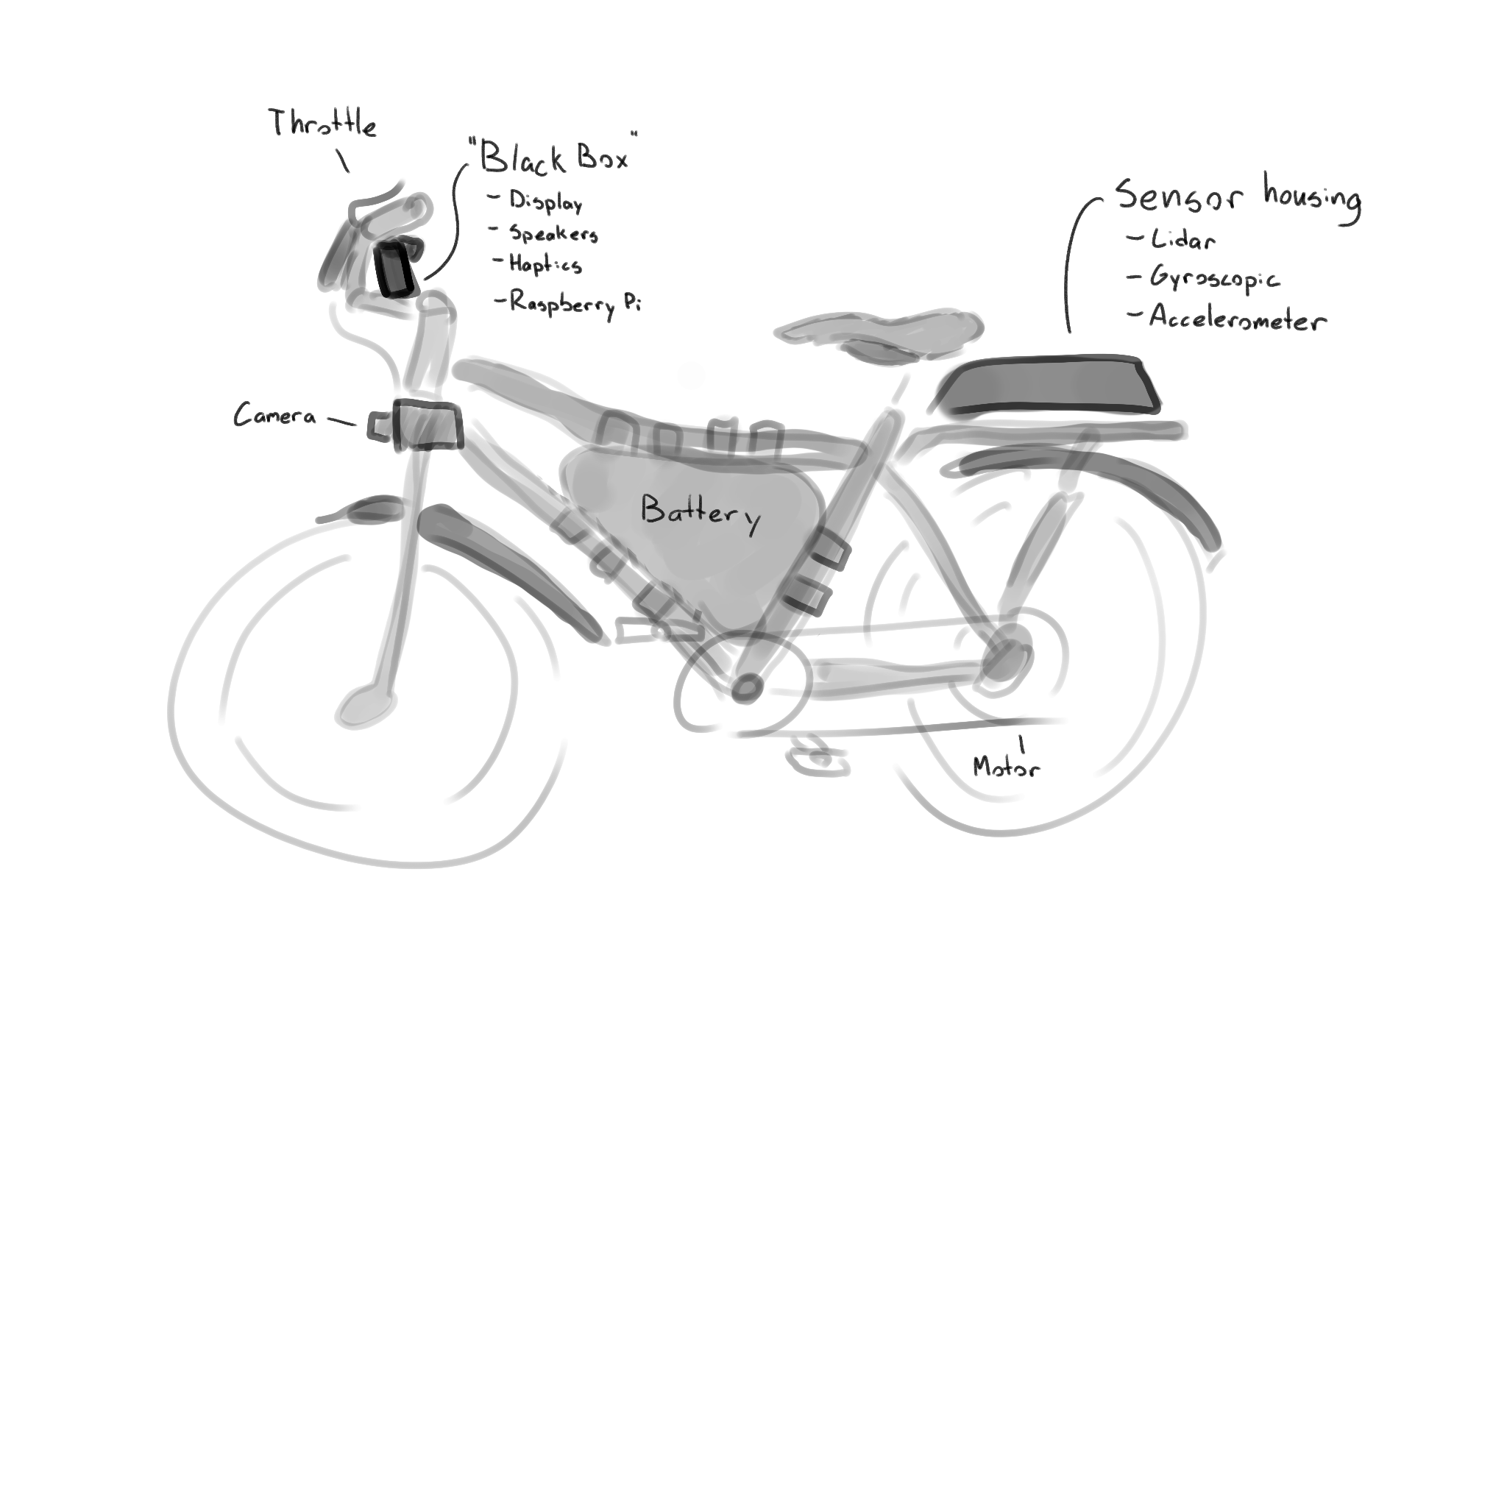

Works CIted

Centers for Disease Control and Prevention, National Center for Injury Prevention and Control.

(2022, May 4). Bicycle Safety. Retrieved December 14, 2023, from https://www.cdc.gov/

transportationsafety/bicycle/

index.html#:~:text=Deaths%20and%20Injuries,the%20United%20States%20every%20year.